Lecture 2.3.4
Lagrange's Theorem

Course outcome to be covered:
CO2: Apply and recognized about the Lagrange's Theorem

Lagrange Theorem
Lagrange theorem was given by Joseph-Louis Lagrange. Lagrange theorem states that in group theory, for any finite group say G, the order of subgroup H (of group G) is the divisor of the order of G i.e., O(G)/O(H). The order of the group represents the number of elements. In this lesson, let us discuss the statement and proof of the Lagrange theorem in Group theory. Lagrange theorem is one of the important theorems of abstract algebra. We will also have a look at the three lemmas used to prove this theorem with the solved examples. The understanding of a coset is also essential before you can fully understand the Lagrange theorem.

Lagrange Theorem Statement
Lagrange theorem states that the order of the subgroup H is the divisor of the order of the group G. This can be represented as;
|G| = |H|
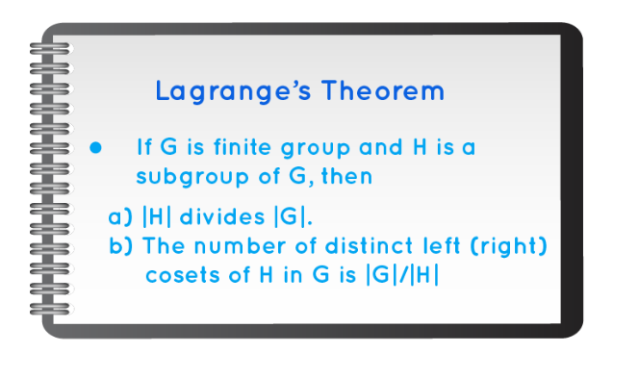

Before understanding the proof of the Lagrange theorem, you need to understand some important terminologies and three lemmas that help us prove this theorem.

Coset
One must understand what a coset is before one can fully understand the Lagrange theorem. Let us understand the coset.
When G is a finite group, and H is a subgroup of G, given that g is an element of G, then;
gH = {gh: h an element of H } will be the left coset of H in G with respect to the element of G and Hg = {hg: h an element of H } is the right coset of H in G with respect to the element of G.
Now, let us understand the three lemmas that help us prove the Lagrange theorem.
Lemma 1: If G is a finite group and H is its subgroup, then there is a one on one correspondence between H and any coset of H.
Lemma 2: If G is a finite group and H is its subgroup, then the left coset relation, g1 ∼ g2 if and only if g1 ∗ H = g2 ∗ H is an equivalence relation.
Lemma 3: Let S be a set and ∼ be an equivalence relation on S. If A and B are two equivalence classes with A ∩ B = ∅, then A = B.

Lagrange Theorem Proof
With the help of the above-mentioned three lemmas, we can easily prove the Lagrange statement.
Proof of Lagrange Statement:
Let H be any subgroup with an order 'n' of a finite group G of order m. Let us consider the coset breakdown of G with respect to H. Now considering that each coset of aH comprises n different elements.
Let H = {h1,h2,…,hn}, then ah1,ah2,…,ahn are the n number of distinct members of aH.
Suppose, ahi=ahj⇒hi=hj be the cancellation law of G. Now G is a finite group, so the number of discrete left cosets will also be finite, say p. So, the total number of elements of all cosets is np which is equal to the total number of elements of G. Hence, m=np
p = m/n
This shows that n, the order of H, divides m i.e., is a divisor of m, the order of the finite group G. We also see that the index p is also a divisor of the order of the group.
Hence, proved, |G| = |H|

Lagrange Theorem Corollary
To prove some corollaries relating to Lagrange's theorem.
Corollary 1: If G is a group of finite order m, then the order of any a∈G divides the order of G and in particular a^{m} = e.
Proof: Let the order of a be p, which is the least positive integer, so,
a^{p} = e
Then we can say,
a, a², a³, …., a^{p-1},a^{p} = e, the elements of group G are all different and they form a subgroup. Since the subgroup has order p, thus p the order of a is the divisor of group G.
So, we can write, m = np, where n is a positive integer.
So, a^{m} = a^{np} = (a^{p})^{n} = e
Hence, proved.
Corollary 2: If the order of finite group G is a prime order, then it does not have proper subgroups.
Proof: Let us suppose, the prime order of group G is m. Now, m will have only two divisors 1 and m (prime numbers property). Thus, the subgroups of G will be {e} and G itself. So, there are no proper subgroups. Hence, proved.
Corollary 3: A group of prime order (the order has only two divisors) is a cyclic group.
Proof: Suppose, G is the group of prime order of m and a ≠ e ∈ G.
As the order of a divides m, it will be either 1 or m. But the order of a, o(a) ≠ 1, since a ≠ e. Therefore, the order of o(a) = p, and the cyclic subgroup of G generated by a are also of order m.
This proves that G is nothing but the same cyclic subgroup formed by a, i.e. G is cyclic.
Important Notes on Lagrange Theorem
- Lagrange theorem states that the order of the subgroup H is the divisor of the order of the group G.
- If G is a group of finite order m, then the order of any a∈G divides the order of G and in particular am = e.
- If the order of finite group G is a prime order, then it has no proper subgroups.
- A group of prime order (the order has only two divisors) is a cyclic group.
Example:
If G is a finite group then let P be a subgroup of G. Suppose that the order n of P is relatively prime to the index |G:S|=m. Using the Lagrange theorem prove that N={a∈G∣a^{n}=e}.
We know that n and m are relatively prime integers, there exits s,t∈Zs,t∈Z such that
sn+tm=1.........................(i)
Also, note that as the order of the group G/N is |G/N|=|G:N|=m, we have
g^{m}N = (gN)^{m} = N
for any g∈G by Lagrange’ theorem, and thus
g^{m}∈N.............................(ii)
Now prove that N={a∈G∣a^{n}=e}.
Suppose a∈{a∈G∣a^{n}=e}. Then we have a^{n}=e.
It follows that
a=a^{sn+tm} = a^{sn}a^{tm} = a^{tm} = (a^{t})^{m}∈N
by (ii).
This proves that {a∈G∣a^{n}=e}⊂N.
On the other hand, if a∈N, then we have a^{n}=e as n is the order of group N.
Hence N⊂{a∈G∣a^{n}=e}.
Putting together these inclusions will yield that N={a∈G∣a^{n}=e} as required.
Answer: Hence proved N={a∈G∣a^{n}=e}

eBook Discrete Mathematics :
http://www.math.unikonstanz.de/~gregory/Algebra3/skript17.pdf

Video link:
https://www.youtube.com/watch?v=TCcSZEL_3CQ&list=PLi01XoE8jYoi3SgnnGorR_XOW3IcK-TP6&index=7

